Step 3: Comparing my students’ in- and out-of-school literacy practices
What should I compare?
Data analysis model template

1) Analysis of data from in-school literacy practices:
I observe the data collected from the tools I used to study children’s in-school literacy practices (questionnaires, interviews, etc.). In each circular section of the diagram, I record: (a) the media most frequently used by children in their in-school practices, (b) the content and culture (high or popular/mass culture) they focus on, and (c) the degree of agency that children have in these practices.
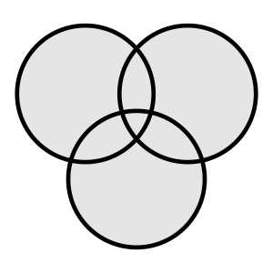

Means
Agency
Content
In-school literacy practices
2) Analysis of data from out-of-school literacy practices:
I observe the data collected from the tools I used to study children’s out-of-school literacy practices (questionnaires, interviews, etc.). In each circular section of the diagram, I record: (a) the media most frequently used by children in their out-of-school practices, (b) the content and culture they focus on (high or mass culture), and (c) the degree of agency that children have in these practices.

Means
Agency
Content
Out-of-school literacy practices

3) Comparison of the two diagrams above
I compare the two diagrams above in order to examine the practices in which children are involved in the two contexts. Specifically, I compare: (a) the media they use, (b) the content and cultural orientation they focus on (high or mass culture), and (c) the degree of agency that children have in these practices.
I then record my evaluation of the degree of convergence and divergence in each aspect.

Means
Agency
Content
Convergences and Divergences

